3 November 2017

Team Leader Local Planning

Southern Region

Department of Planning & Environment

PO Box 5475

WOLLONGONG NSW 2520

**Shellharbour Local Environmental Plan 2013 Planning Proposal No 0005/2016: Shellharbour Surf Club**

Dear Sir

Council at its meeting held on 31 October 2017 resolved to prepare a Planning Proposal to amend Shellharbour Local Environmental Plan 2013. The Planning Proposal is for Lot 1 DP 211127 and part of Lot 5 DP 218551.

The Planning Proposal is to amend Shellharbour LEP 2013 to reclassify land from community to operational and amend Schedule 1 of LEP 2013 to permit function centres as an additional permitted use

Council does not propose to use its plan making delegation under Section 59 of the *Environmental Planning & Assessment Act 1979*.

Under Section 56 of the *Environmental Planning & Assessment Act 1979,* the Planning Proposal is attached for your consideration.

Please contact me on 4221 6126 if you need more information.

Yours sincerely

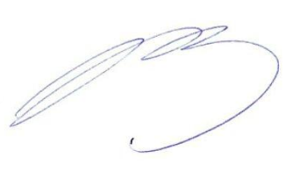

Michael Tuffy

**Senior Strategic Planner**

**Attached**

* Planning proposal and its attachments